Calculus II Final Exam

LAST Name:

FIRST Name:

Please check that you have 12 pages, INCLUDING this cover page.
Use the spaces beside the questions and the backs of the question pages for your rough work. There are 25 multiple choice questions and five written pages. (The last two pages offer a choice!)

GOOD LUCK

Multiple choice: Written Portion:

/25 1) /9

2) /9

3) /11

4) or 5) /9

TOTAL /38

PLEASE MAKE SURE YOU HAVE FILLED IN AND DOUBLE CHECKED ON THE COMPUTER SHEET YOUR
1) LAST NAME
2) INITIAL(S)
3) ID NUMBER

FOR EACH QUESTION, CIRCLE YOUR CHOICE FOR THE CORRECT ANSWER AND FILL IN THE CORRESPONDING BUBBLE ON THE COMPUTER ANSWER SHEET. (USE THE SPACE TO THE RIGHT OF THE QUESTIONS OR THE BACK OF THE EXAM PAGES FOR YOUR ROUGH WORK.)

1. The domain of is

2. The exact value of arccos(cos(11/9)) is

3. The exact value of sin(arccos(–2/3)) is

4.

5.

6.

8. The three values for “exponent” that make the integral

EASIEST, NEXT EASIEST, and NEXT EASIEST AGAIN, are, in order,

(a) 0, 9, 19 (b) 9, 19, 29 (c) 10, 20, 30 (d) 9, 18, 27 (e) 0, 9, 18

9. If sinh(x) = −5, then cosh(x) is

11. Which of the following is NOT an indeterminate form?

13. One parametrization of the ellipse
which starts at (–5, 0) and travels clockwise to (0, –6) is given by

(a) x = –5sin(t), y = 6cos(t), t [/2, ]

(b) x = 5sin(t), y = 6cos(t), t [–/2, ]

(c) x = 5sin(t), y = –6cos(t), t [–/2, ]

(d) x = –5sin(t), y = 6cos(t), t [–/2, ]

(e) x = –5sin(t), y = –6cos(t), t [–/2, ]
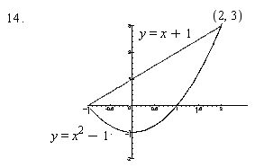

The volume obtained when revolving the bounded region in the diagram above about the line
y = 3 is given by

(a) vertical asymptote x = ln(2) and horizontal asymptotes y = 0 and y = –1/2

(b) horizontal asymptote x = ln(2) and vertical asymptotes y = 0 and y = –1/2

(c) vertical asymptote x = ln(2) and horizontal asymptote y = 0

(d) vertical asymptote x = ln(2) and horizontal asymptote y = –1/2

(e) vertical asymptote y = ln(2) and horizontal asymptotes x = 0 and x = –1/2

17. If y = sin(t) and x = tan(t), it can be shown that cos³(t). Using this, equals

(a) 3cos⁴(t) (b) 3cos⁴(t) sin(t) (c) –3cos⁴(t)

(d) (e) –3cos⁴(t) sin(t)

18. At what value(s) of t does the curve given by x = e^{t} –3t and y = t² –t have a vertical tangent?

(a) 1/2 (b) 0 and 1 (c) 3 (d) ln(3) (e) There are no vertical tangents.

19.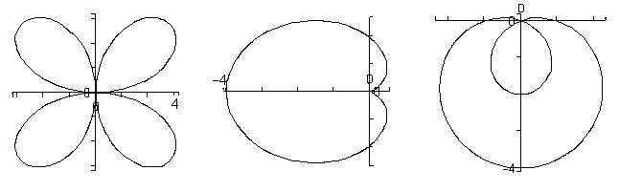
I II III

Polar equations for I, II, and III, in that order are

(a) r = 4cos(2), r = 2 –2cos(), r = 1 –3sin()

(b) r = 4sin(2), r = –2 + 2cos(), r = 1 –3sin()

(c) r = 4cos(2), r = 2 –2cos(), r = –1 + 3sin()

(d) r = 4sin(2), r = 2 –2cos(), r = 1 –3sin()

(e) r = 4sin(2), r = 1 –3sin(), r = 2 –2cos()

20. The point with rectangular coordinates has as one set of polar coordinates

21. All possible polar coordinates for the point are given by

22. Which one of the following is false?

(a) One method to find the MacLaurin series for cos(x) is to differentiate the series for sin(x).

(b) If a function has a MacLaurin series, this series is unique.

(c) The MacLaurin series for can be obtained by polynomial division.

(d) is true for every real number x except x = 1.

(e) To find the MacLaurin series for sin(5x), substitute 5x for x in the series for sin(x).

23. The surface has domain

(a) outside the circle x² + y² = 25, including the circle and excluding the line x = –3.

(b) outside the circle x² + y² = 25, including the circle and excluding the line x = 3.

(c) inside the circle x² + y² = 25, excluding the circle and excluding the line x = –3.

(d) inside the circle x² + y² = 25, excluding the circle and excluding the line x = 3.

(e) outside the circle x² + y² = 25, excluding the circle and excluding the line x = –3.

24. Given z = sin(xy) + 4x² + 3y , the partial derivative

(a) cos(xy)(x + y) + 8x + 3 (b) ycos(xy) + 8x (c) ycos(xy) + 8x + 3

(d) cos(xy) (y + xdy/dx) + 8x + dy/dx (e) cos(xy) + 8x + 3

25.

PART 2:
1. (a) State the domain and range and sketch the graph of , labeling two points on the graph.

Domain: __________________ Range: ___________________

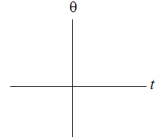
/3

(b) Now consider another function: (Note: not arcsin!) It has domain and range . Derive the formula for
Your derivation should at some point consider both.

/6

2. (a)

/3

(b) (Hint: use trig substitution!)

/6

(c) To evaluate the integral , we first write Find A, B, and C. (Do not complete the integration.)
/3
3. The relation defined by the parametric equations has first and second derivatives

(a) Determine all x and y intercepts.

/2

(b) Determine on the t number line below the t intervals on which the relation is increasing and the t intervals on which the relation is decreasing. State POINTS (x, y) at which there are horizontal tangents or vertical tangents.
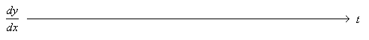

/4

(c) Determine on the t number line below the t intervals on which the relation is concave up and the t intervals on which the relation is concave down. State any POINTS OF INFLECTION.
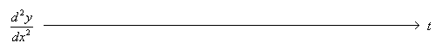

/3

(d) Complete the table and draw the graph, labeling the intercepts, maximum, minimum and inflection points with both (x, y) coordinates and the corresponding t value. Use an arrow to show the direction of increasing t on the graph.
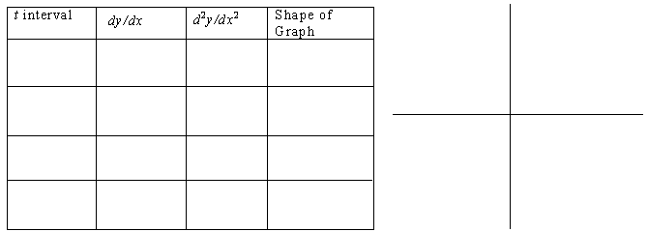

/2
DO ONLY ONE OF QUESTIONS 4 AND 5. “I CHOOSE TO DO QUESTION !”
4. (a) Evaluate the following limit using L'Hôpital's Rule. State, in quotes, the indeterminate form involved at each appropriate step.

/3

(b) (Hint: This is an improper integral.)

/3

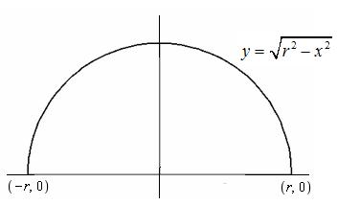
(b) Set up the integral, first as a limit and then using integral notation, which will evaluate the volume of a sphere of radius r. (Illustrate a typical rectangle rotated about the x axis.) Do not evaluate the integral.

/3

REMEMBER YOU ARE TO DO ONLY ONE OF QUESTIONS 4 AND 5. 5. (a) Assuming that we are able to write , find, using an appropriate x value and derivatives, the coefficients By this time, you should see the pattern. (If not, find a few more ) Using the pattern, write out the infinite polynomial series, that is, the MacLaurin series, for cosh(x). Hint: sinh(0) = 0 and cosh(0) = 1.

/4

/3

/1

(iii) In one step, give the MacLaurin series for .

/1

