Calculus I Midterm 2

First Name: __________________ Last Name: _____________________
Signature: ____________________

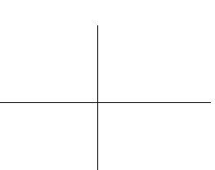

1. (a) Complete and illustrate the definition:

/2
2. Evaluate the following limits. (Show the method!)
(a) (b)

/2 /2

3 (a) Complete the definition: A function is continuous at if
(i)
/1 (ii)
(iii)
(b) Give an example of a function that is continuous but not differentiable at
/1
4. Given from the definition of the derivative, that is, from first principles.
/3

5. (a) Given

/3

(b)
/3

6. Using the differential, estimate without a calculator! Identify your choice of Give the EXACT value of your estimate. (This is not a contradiction in terms.) Give your answer as a fraction.

/3

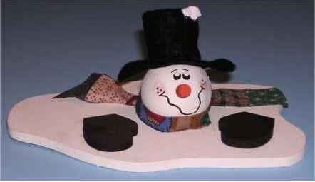
7. The radius of a spherical snowperson's head is melting under the MILD sun at the rate of cm/h (centimetres per hour.) Find the rate at which the volume is changing when the volume is cm³. (The volume of a sphere is given by .)

/3

8. State the vertical and horizontal asymptotes of the function .

/2
(a) Find the x and y intercepts.

/2

(b) Analyze (x) using a number line, indicating intervals where the function is increasing or decreasing. Identify maximum and minimum points.
State whether these extreme points have vertical or horizontal tangents.

/3

(c) Analyze (x) using a number line, indicating intervals where the function is concave up or concave down, and identify any points of inflection. State the slope at each inflection point.

/3

(d) OPTIONAL BUT IF THE GRAPH IS WRONG YOU CAN EARN PART MARKS
x interval y′ y ′′ shape
_____________________________________________
_____________________________________________
_____________________________________________
_____________________________________________

(e) Accurately draw the graph,
scaling appropriately, and
labeling important points.

/2

10. (a) Prove Fermat’s Theorem: Let be a continuous function on . Suppose that for some is a relative maximum point and that exists. Prove that

/6

